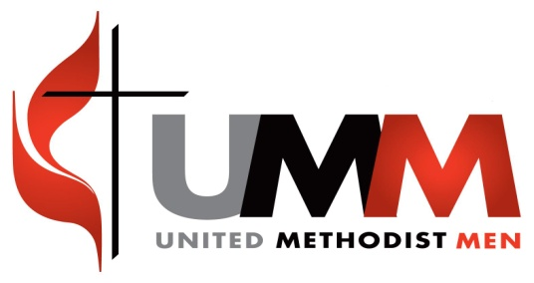
Iron Men of SWUMC
Meeting Minuets Date: 09/18/2015
-Meeting was opened with the reading of Romans 3: 1-8
-Welcome back, School is back in session.
-Next regular meeting is 10/15/15 at 7pm.
-We approved the ordering of
Please go to www.themangerbuild.org for more info. We will make final decision at the next meeting.
-Oct 27th is the YRDUMM fall general district meeting at Bethany UMC. 6:30pm-8:30pm, cost w/dinner $8.00? Registration due by Oct 25th.
-Oct 24th Iron sharpens Iron conference at Bethel Baptist in Yorktown. Also Apr 16th in Richmond
-Oct 3rd is the planned Church grounds cleanup day.
-Nov 29th is 5th Sunday. WE NEED TO HAVE 02 VOLLUNTEERS FROM THE MEN’S GROUP TO DO CHILDRENS CHURCH FOR 4YR OLDS TO 3RD GRADE.
Coming up
- We discussed doing the Peanut fundraiser again with positive interest.
- We are looking to vote in a Vice President possibly.
-GUEST program is around the corner.
-Helping hands may need help finishing a house, waiting to hear back from Randy.
-Ignite Conference in Lynchburg is in March, plan to go.
Funding
-Current account balance. $1183.48
-The meeting was closed with a prayer.
Attendance
- Jonathan Keough, Treasury/Secretary
- Ray Church, Member
- Mark Tartaglia, Member

